Test Case: tc006_SPX_Dev5_Crear_Requisicion_Spot_Tipo_Cobro_Proyect_Urgent
Step 1 - Enter username and password and click to button Enter: Credentials Entered
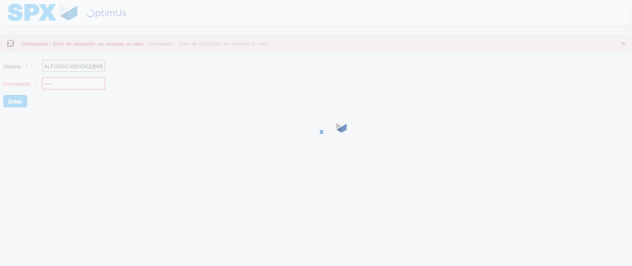Image file-name: QC_Testing-tc006_SPX_Dev5_Crear_Requisicion_Spot_Tipo_Cobro_Proyect_Urgent-1783377182477

Step 2 - Select to UEN and Access to Spot Buy Requisitions : UEN Correctly selected and Correct access
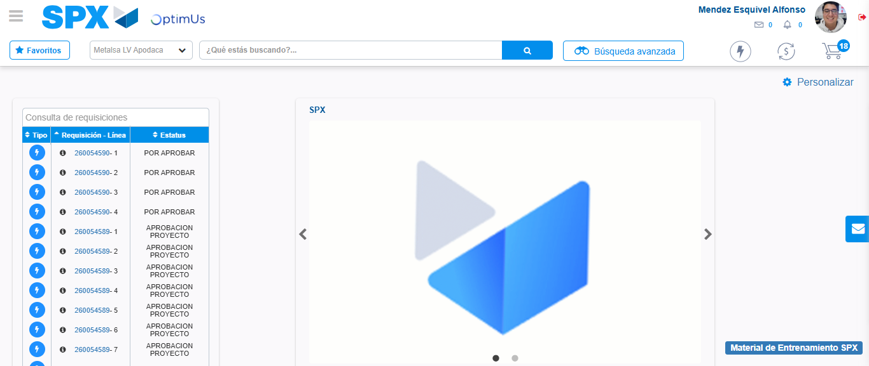Image file-name: QC_Testing-tc006_SPX_Dev5_Crear_Requisicion_Spot_Tipo_Cobro_Proyect_Urgent-1783377207918

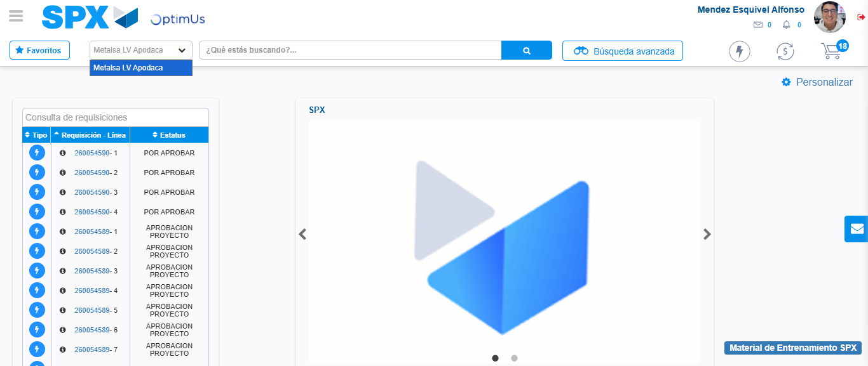Image file-name: QC_Testing-tc006_SPX_Dev5_Crear_Requisicion_Spot_Tipo_Cobro_Proyect_Urgent-1783377210369

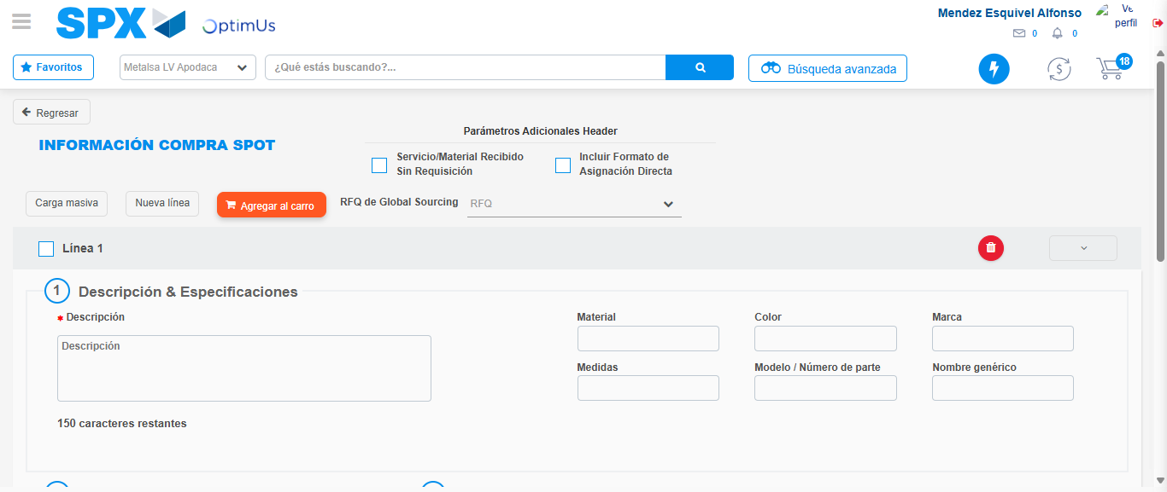Image file-name: QC_Testing-tc006_SPX_Dev5_Crear_Requisicion_Spot_Tipo_Cobro_Proyect_Urgent-1783377230891

Step 3 - Data Capture Spot Buy Requisition: Data captured correctly
Image file-name: QC_Testing-tc006_SPX_Dev5_Crear_Requisicion_Spot_Tipo_Cobro_Proyect_Urgent-1783377231138

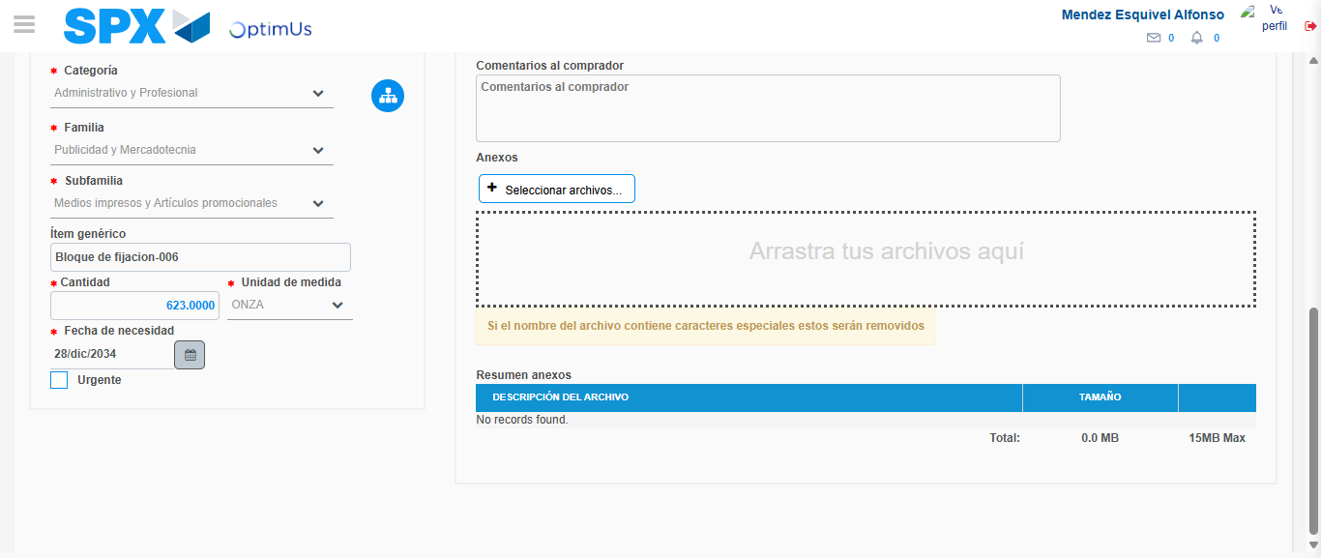Image file-name: QC_Testing-tc006_SPX_Dev5_Crear_Requisicion_Spot_Tipo_Cobro_Proyect_Urgent-1783377241640

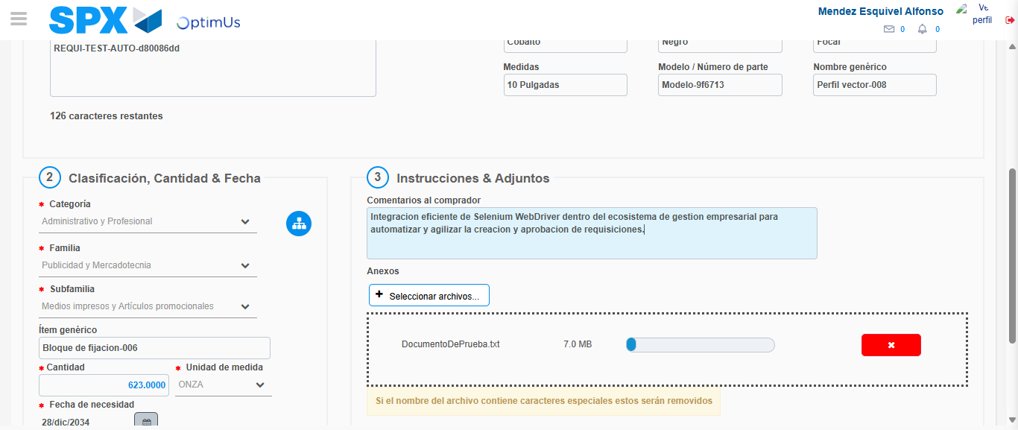Image file-name: QC_Testing-tc006_SPX_Dev5_Crear_Requisicion_Spot_Tipo_Cobro_Proyect_Urgent-1783377242324

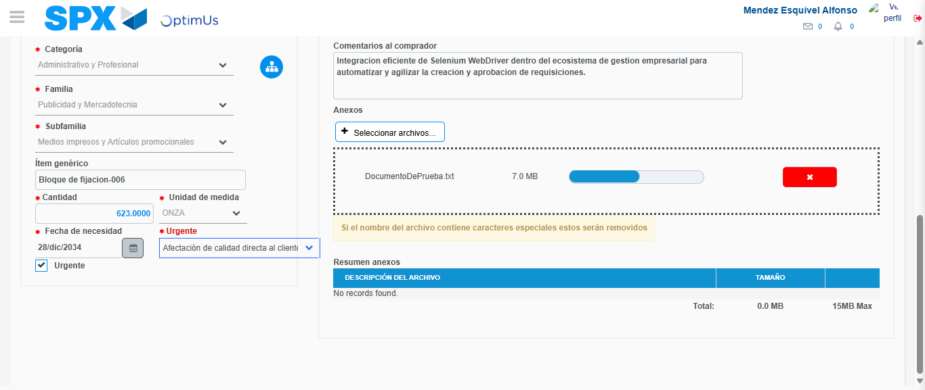Image file-name: QC_Testing-tc006_SPX_Dev5_Crear_Requisicion_Spot_Tipo_Cobro_Proyect_Urgent-1783377245411

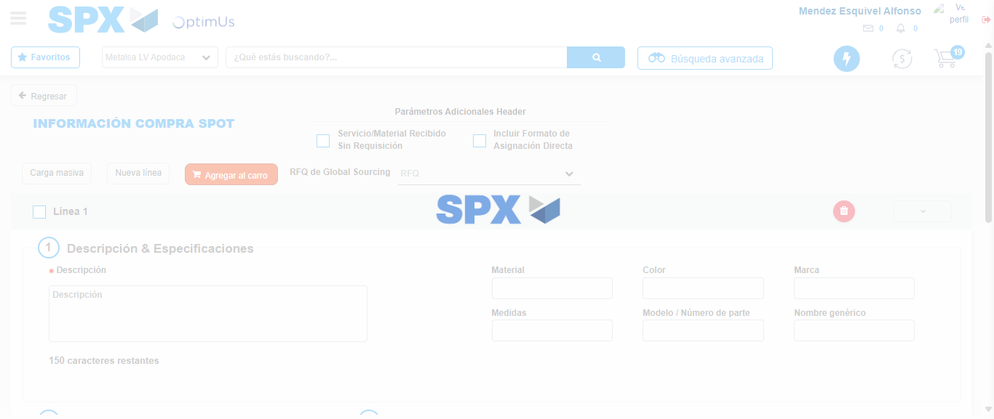Image file-name: QC_Testing-tc006_SPX_Dev5_Crear_Requisicion_Spot_Tipo_Cobro_Proyect_Urgent-1783377253864

Step 7 - Return to Main Page SPX : Return to Main Page SPX
Image file-name: QC_Testing-tc006_SPX_Dev5_Crear_Requisicion_Spot_Tipo_Cobro_Proyect_Urgent-1783377207918

Image file-name: QC_Testing-tc006_SPX_Dev5_Crear_Requisicion_Spot_Tipo_Cobro_Proyect_Urgent-1783377210369

Image file-name: QC_Testing-tc006_SPX_Dev5_Crear_Requisicion_Spot_Tipo_Cobro_Proyect_Urgent-1783377230891

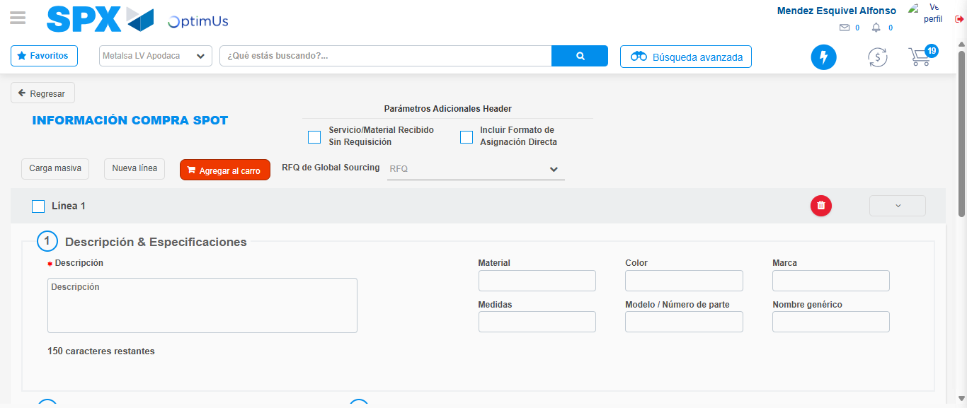Image file-name: QC_Testing-tc006_SPX_Dev5_Crear_Requisicion_Spot_Tipo_Cobro_Proyect_Urgent-1783377256168

Image file-name: QC_Testing-tc006_SPX_Dev5_Crear_Requisicion_Spot_Tipo_Cobro_Proyect_Urgent-1783377256360

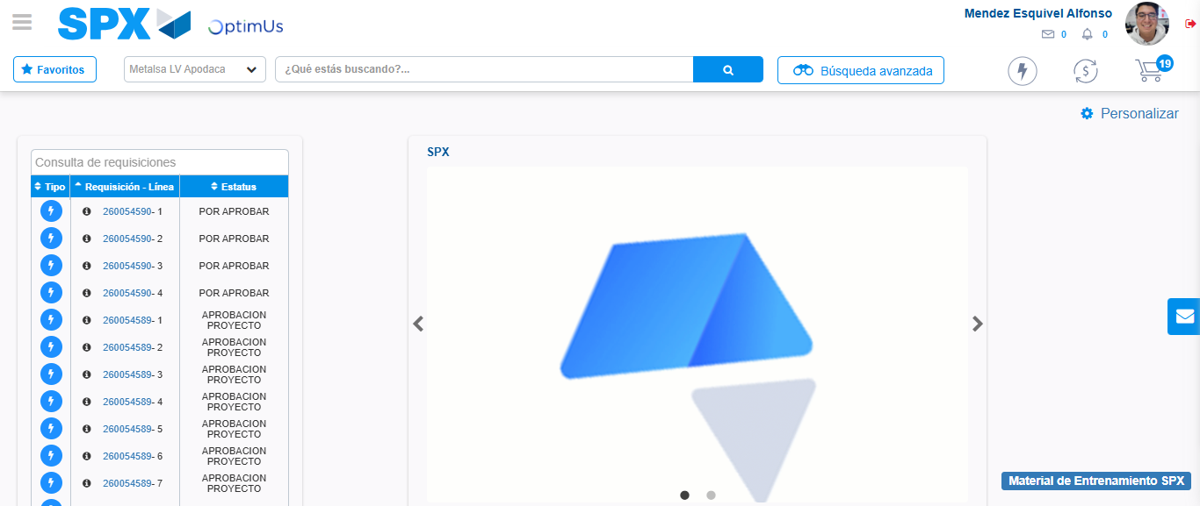Image file-name: QC_Testing-tc006_SPX_Dev5_Crear_Requisicion_Spot_Tipo_Cobro_Proyect_Urgent-1783377277438

Step 8 - Log Out : Log Out SPX
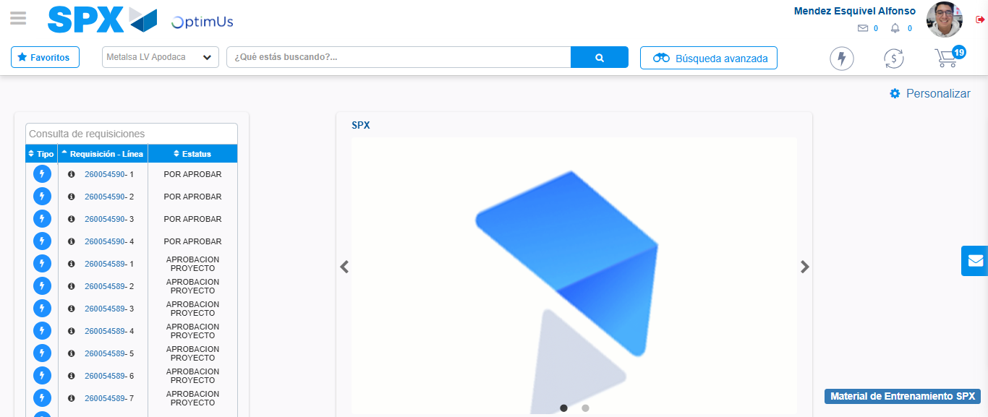Image file-name: QC_Testing-tc006_SPX_Dev5_Crear_Requisicion_Spot_Tipo_Cobro_Proyect_Urgent-1783377277688

